Big chungus

**Questions**

1. What is the smallest memory object that can represent a character of information?
   1. Think… How many upper case letters in the alphabet (A to Z)?
      * 26
   2. Think… How many lower case letters in the alphabet (a to z)?
      * 26
   3. Think… How many number digits (0 to 9)?
      * 10
   4. Think… How many punctuation marks?
      * 14
   5. Add them all up
      * 76
2. Research the ASCII characters set. What is it and how is it related to computer memory?  
   * + The ASCII character set is related to computer memory because each character in it is one byte.
3. How are strings of characters (Google “String”) represented in computer memory?
   * + Strings are used in python and can be 1 character so it would take up a variable amount of bytes.
4. How are negative integers represented in computer memory? (Include a diagram)  
   * + Integers are stored in two’s compliment which is a way of signing negative signed numbers.

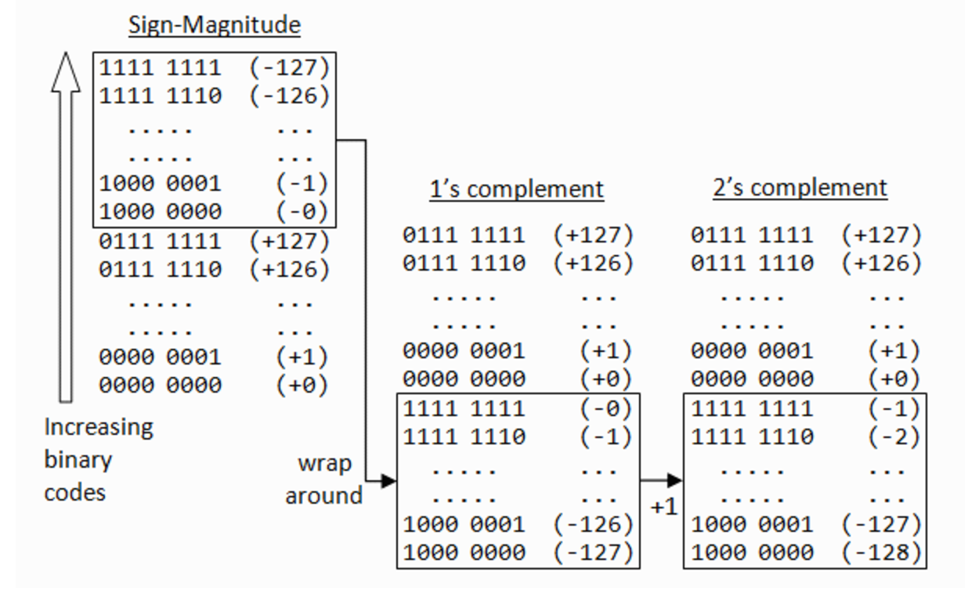

1. How are decimal numbers (Google “Floating Point”) represented in computer memory? (Include a diagram)

Floating point format usually is represented by 64bits in computer memory

1. A Pixel is computer memory structure used to store image information. How is a Pixel represented in memory? (Include a diagram).

pixels are stored in computer memory as a raster image , a two-dimensional array of small integers.

